 Summer Solstice Issue
***********************************************************

Next meeting: Sunday, June 14, 2009

Doors Open: 1 pm, business meeting at 1:30 pm, speaker begins at approximately 1:45 -2 pm.

Location: Stacy’s Furniture Store, 3rd floor community room
1900 S. Main St.
Grapevine, TX
Map on last page of newsletter.

Speaker: Mira Cosic

Topic: Overcoming Language and Culture Barriers: With a Little Help from Mercury
Learn how to share information and astrological experience to different corners of the world. Individual cultural differences abound, therefore your approach to the client's needs has must be very unique. Learn how to shift your views and respond in culturally appropriate ways if you have clients in different countries, over the phone, via internet, or if you write for magazines published in other parts of the world. Examples will be given for several different countries including government influence, taboos and limitations they impose.

Mira is going to present this same material in August, at the ISAR 2009 in Chicago.

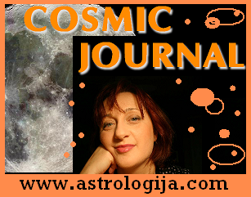
Mira Cosic is the new president of ASNT and a practicing astrologer since 1987. This is when she discovered the March and McEvers book series, "The Only Way to Learn Astrology," published for the first time in her native Sarajevo, Bosnia. There were no astrology teachers or practitioners in socialist, conservative Bosnia at the time; there was also no astrology on radio or TV, and no horoscope columns in newspapers. Mira became a pioneer of astrology in her country when in 1990. she started hosting a weekly live astrology show at the popular radio station "Sarajevo 202". This was the first time that a radio station in her country would let an astrologer speak publicly. The show was on the air on Saturday afternoon, phone lines rang off the hook and the station started receiving hundreds of letters supporting the show and encouraging astrology!
After two years at "202," the war in Bosnia began and the station went off the air but that didn't stop her. She moved her show to ISV Radio and then widely popular "Radio M" in Sarajevo.
During the three years of war in Bosnia, she rode her bicycle to the radio station at night during curfew to avoid snipers. She was on the forefront of opening the newly free Bosnia to new age ideas, editing and writing a daily astrological and spiritual page for a well-known Bosnian daily national newspaper which had never published anything about astrology before, and many articles for several astrological and other monthly and weekly magazines in both Serbian and Croatian languages. Bosnian National TV and local TV Hayat had a series of prime-time shows about astrology where Mira made several guest appearances.
After moving to the US, Mira developed expertise in various areas of astrology studying modern, evolutionary and traditional techniques with well-known astrologers, working as a volunteer for ISAR and UAC conferences, becoming a speaker, board member and webmaster for ASNT. Along the way, she has interviewed famous astrologers, and written articles about major American astrological events and organizations for various magazines in her native Bosnia and neighboring Serbia.
She returns to Bosnia periodically where she still has a following, to conduct astrological seminars. Currently, she provides teleclasses, "Astro Logija Dot Cosm - Cosmic Journal" newsletter and podcasts on astrology in two languages for her web site http://www.astrologija.com. She also hosted a Saturday night astrological feature called "Voice of the Stars" for RSG Radio in Sarajevo, Bosnia, and recently at the Radio M Sarajevo. Currently, her Internet radio feature in English is being broadcast online.
Mira counsels and teaches internationally in several languages, with clients and students in US, France, Australia, Switzerland, Bosnia, Croatia, Sweden, Serbia, Norway and UK.
True to her Cancer Sun and Uranus in Libra on her ascendant, her counseling is both unique and sensitive, directed towards inner healing and evolution of the soul.
Bottom of Form
Top of Form


 Announcing Your New ASNT officers

President and Web Master: Mira Cosic
Programs: Sandra Williams
Secretary: Melinda Noble
Treasurer: Priscilla Peers
Media Master: Susan Gray
Membership: Donna Henson
Publicity: Dee Emrich
Newsletter: Sandra Soliz

And Goodbye to Sue Watson, off to a new job in Durango, Colorado.
Thanks to all of you for allowing me to be your newsletter editor, and blessing me with your astrological teachings and insight!! I’ll be back to visit, and come see me up in the mountains. Welcome, Sandy!!



President’s Message
June 2009

Reflections

All endings are new beginnings. I’m happy to be ending my term as president of ASNT and I’m looking forward to the fresh ideas and energies of Mira as she starts her term as our new president. I have every confidence she will be a wonderful one. I’m sure all of you will support her as you have been such a wonderful support to me.

I must say though, being responsible for the direction of the group has been a tremendous growth factor and I’m grateful for the opportunity and the trust you’ve had in me to do it. I wasn’t so sure it was well placed when I stepped on that podium the first few times! Susan and Donna were a great resource and personal booster club, and I’m most grateful for their ideas, input, work, and belief in me. It made a huge difference. I’ve been most fortunate to have an absolutely wonderful board these three years and I bless every one of you for your willingness to serve, your continued stepping up to the plate, your good natured camaraderie, and jobs you’ve done. We’ve accomplished a lot together.

I find it interesting that my term saw my health and optimism reach their lowest point, and at the two-thirds mark, to hit bottom and make the turn back toward health. It’s almost like reaching a pinnacle and a bottom of the barrel at the same time. I had not served as president of anything before other than my own (one-person) business. At the same time, I’m not sure I’ve ever been that far into feeling powerless to affect the conditions of my life. There were days I just wanted to give up, turn my face to the wall, and close my eyes. Susan helped me in many, many ways, as did Mira, Ina Crowe, and my kids. It has been a lesson in learning to receive, to say I need help and allow my wonderful friends and kids to step up to the plate and help me get past it.

Through it all, I was thankful for astrology. It is great for helping us see the cycles and to know that “this too shall pass.” Nothing is forever. It’s always about the journey, how we make it, and what we learn along the way. The best thing I really got this past year or two, is that we may be alone in our perceptions, but not in fact.

Live long and prosper!

Sandra


UPCOMING SPEAKERS and tentative topics

July Linda Sprague “Saturn/Uranus opposition in your chart”
August Gene Johnson “A new US chart”- based on the new biography of John Adams, and his certainty in a letter to Abigail that July 2nd would live in history as the Declaration of Independence
September Economic crisis with an intro by Kaye Shinker and a panel discussion
October Mary Buckner “Tidbits of Astrology”
November Susie Patterson -- subject undecided at present
December Topic to be announed
January Rebecca Eigen of Houston. Topic to be announced

Thanks Sandra Williams for your rapid work on this!!
********************************************************************

Parking: Please be sure to park on the sides of the building and not in front. Stacy’s has asked us to be sure and respect their need for the front space for their customers.

Map to Stacy Home Furnishing Center
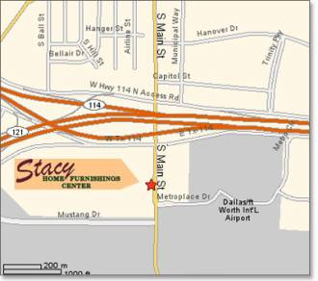

Please bring capped water bottles only. No food

Rick Levine Workshop Photos from April 2009

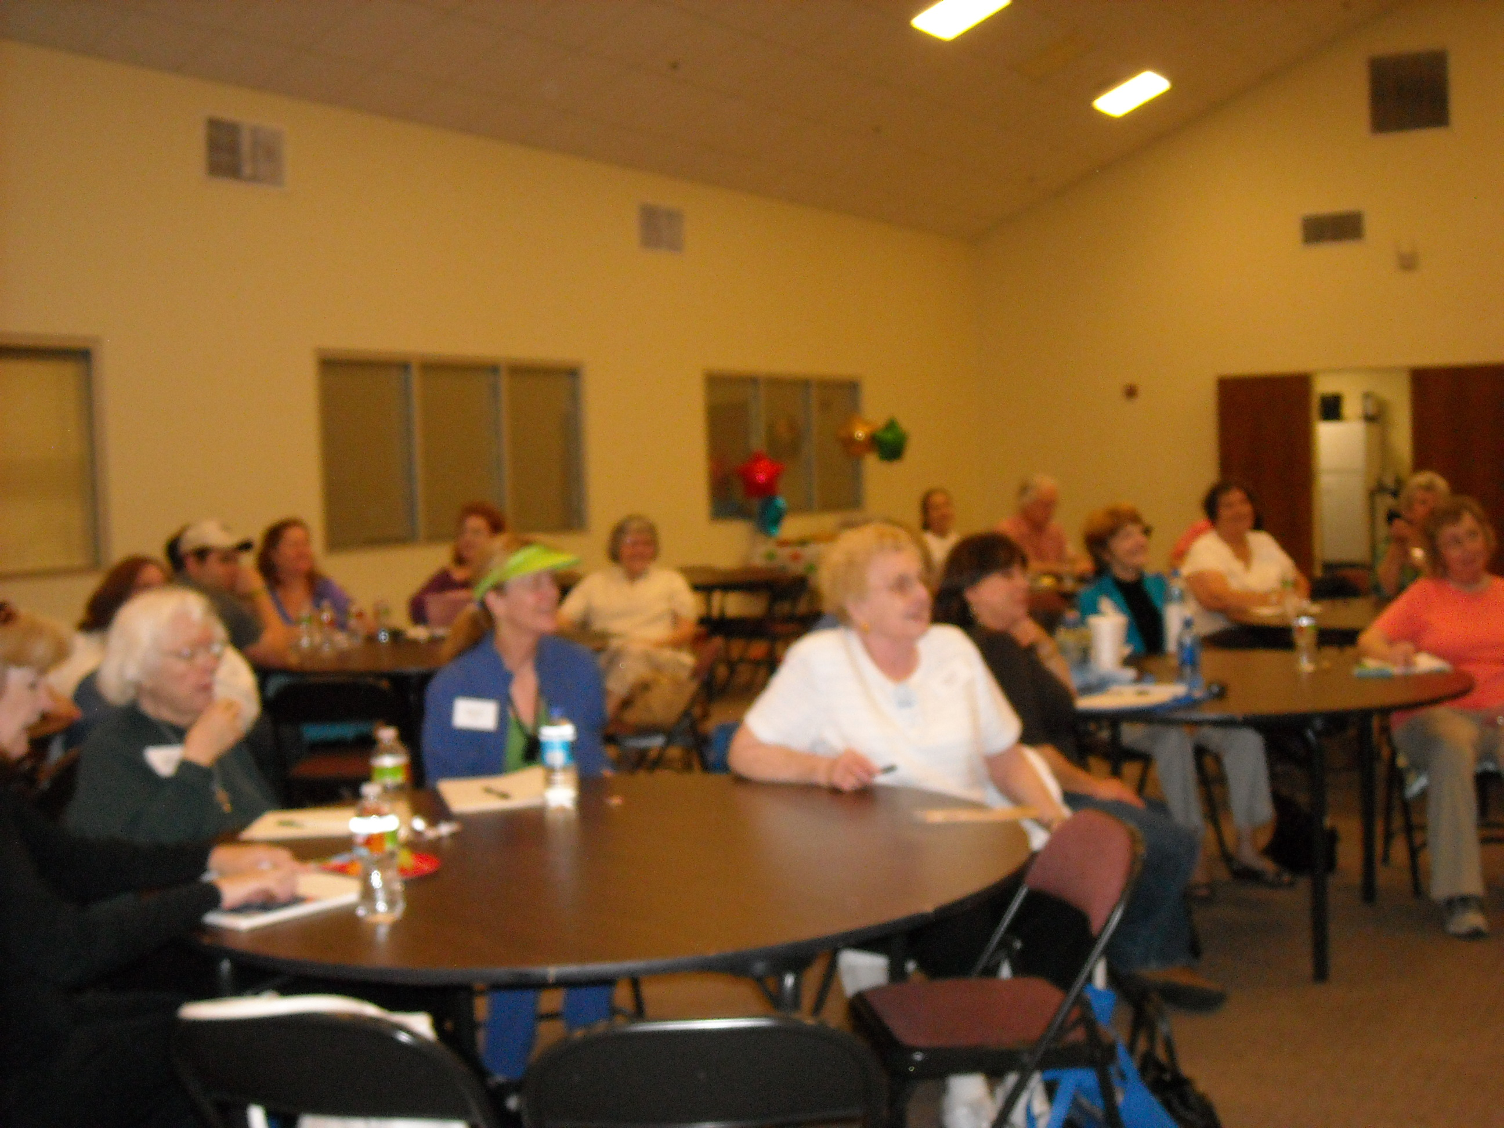 Photo by Kaye Shinker

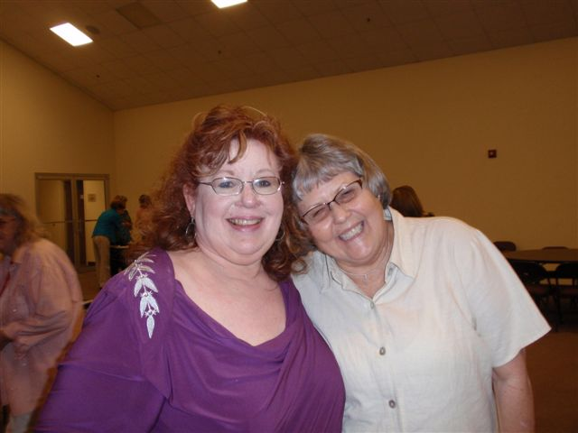
Photos by Marva Mason

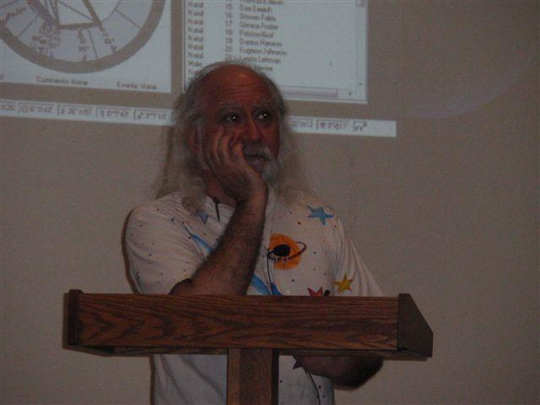
Photo by Marva Mason

Have a great summer!!



